WEEK 2:COGNIZANT FSE HANDS ON EXERCISES
Spring Core and Maven Exercises:
Exercise 1: Configuring a Basic Spring Application

BookService.java
package com.library.service;

import com.library.repository.BookRepository;
import com.library.utility.Logger;

public class BookService {

private BookRepository bookRepository;
private Logger logger;

public BookService(Logger logger) {
this.logger = logger;
}

public void setBookRepository(BookRepository bookRepository) {
this.bookRepository = bookRepository;
}

public void addBook() {
logger.log("Adding a book...");
bookRepository.saveBook();
}
}

BookRepository.java

package com.library.repository;

public class BookRepository {
public void saveBook() {
System.out.println("Book saved to the database.");
}
}

Logger.java

package com.library.utility;
public class Logger {
public void log(String message) {
System.out.println(message);
}
}

Main.java

package org.example;
import com.library.service.BookService;
import org.springframework.context.ApplicationContext;
import org.springframework.context.support.ClassPathXmlApplicationContext;

public class Main {

public static void main(String[] args) {

ApplicationContext context =
new ClassPathXmlApplicationContext("applicationContext.xml");

BookService bookService =
(BookService) context.getBean("bookService");

bookService.addBook();
}
}
Output:

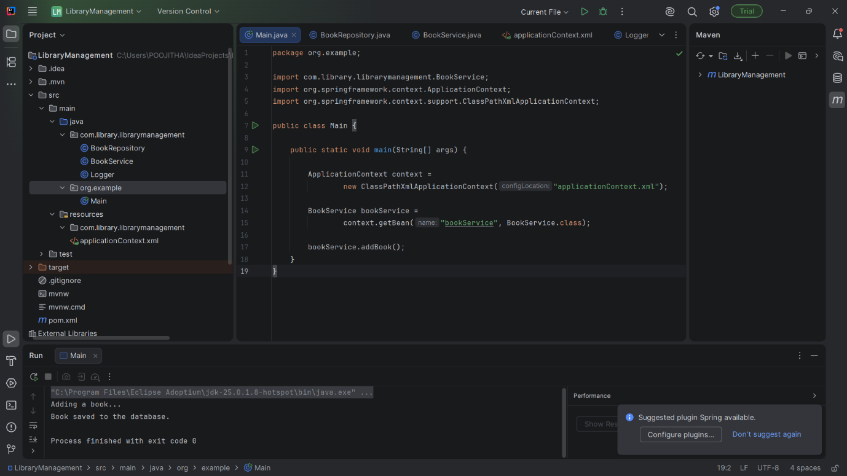

Exercise 2: Implementing Dependency Injection
BookRepository.java

package com.library.repository;

public class BookRepository {

public void saveBook() {
System.out.println("Book saved to the database.");
}
}

BookService.java

package com.library.service;

import com.library.repository.BookRepository;
import com.library.utility.Logger;

public class BookService {

private BookRepository bookRepository;
private Logger logger;

public BookService(Logger logger) {
this.logger = logger;
}

public void setBookRepository(BookRepository bookRepository) {
this.bookRepository = bookRepository;
}

public void addBook() {
logger.log("Adding a book...");
bookRepository.saveBook();
}
}

applicationContext.xml

<?xml version="1.0" encoding="UTF-8"?>

<beans xmlns="http://www.springframework.org/schema/beans"
xmlns:xsi="http://www.w3.org/2001/XMLSchema-instance"
xsi:schemaLocation="
http://www.springframework.org/schema/beans
https://www.springframework.org/schema/beans/spring-beans.xsd">

<!-- Logger Bean -->
<bean id="logger"
class="com.library.utility.Logger"/>

<!-- BookRepository Bean -->
<bean id="bookRepository"
class="com.library.repository.BookRepository"/>

<!-- BookService Bean -->
<bean id="bookService"
class="com.library.service.BookService">

<!-- Constructor Injection -->
<constructor-arg ref="logger"/>

<!-- Setter Injection -->
<property name="bookRepository"
ref="bookRepository"/>

</bean>

</beans>

OUTPUT:
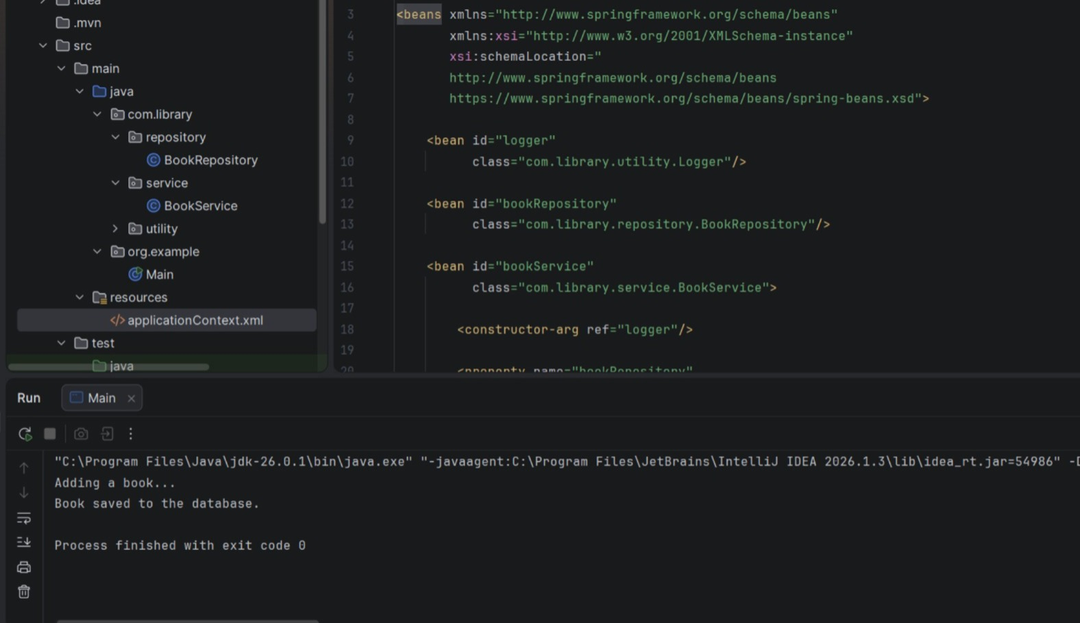

Exercise 4: Creating and Configuring a Maven Project

BookRepository.java

package com.library.repository;

public class BookRepository {

public void saveBook() {
System.out.println("Book saved to the database.");
}
}

BookService.java

package com.library.service;

import com.library.repository.BookRepository;
import com.library.utility.Logger;

public class BookService {

private BookRepository bookRepository;
private Logger logger;

public BookService(Logger logger) {
this.logger = logger;
}

public void setBookRepository(BookRepository bookRepository) {
this.bookRepository = bookRepository;
}

public void addBook() {
logger.log("Adding a book...");
bookRepository.saveBook();
}
}

POM.XML

<?xml version="1.0" encoding="UTF-8"?>

<project xmlns="http://maven.apache.org/POM/4.0.0"
xmlns:xsi="http://www.w3.org/2001/XMLSchema-instance"
xsi:schemaLocation="http://maven.apache.org/POM/4.0.0
http://maven.apache.org/xsd/maven-4.0.0.xsd">

<modelVersion>4.0.0</modelVersion>

<groupId>org.example</groupId>
<artifactId>SpringExample</artifactId>
<version>1.0-SNAPSHOT</version>

<properties>
<maven.compiler.source>17</maven.compiler.source>
<maven.compiler.target>17</maven.compiler.target>
<project.build.sourceEncoding>UTF-8</project.build.sourceEncoding>
</properties>

<dependencies>

<!-- Spring Context -->
<dependency>
<groupId>org.springframework</groupId>
<artifactId>spring-context</artifactId>
<version>5.3.33</version>
</dependency>

<!-- Spring AOP -->
<dependency>
<groupId>org.springframework</groupId>
<artifactId>spring-aop</artifactId>
<version>5.3.33</version>
</dependency>

<!-- Spring Web MVC -->
<dependency>
<groupId>org.springframework</groupId>
<artifactId>spring-webmvc</artifactId>
<version>5.3.33</version>
</dependency>

</dependencies>

<build>
<plugins>

<!-- Maven Compiler Plugin -->
<plugin>
<groupId>org.apache.maven.plugins</groupId>
<artifactId>maven-compiler-plugin</artifactId>
<version>3.8.1</version>

<configuration>
<source>17</source>
<target>17</target>
</configuration>

</plugin>

</plugins>
</build>

</project>

OUTPUT:

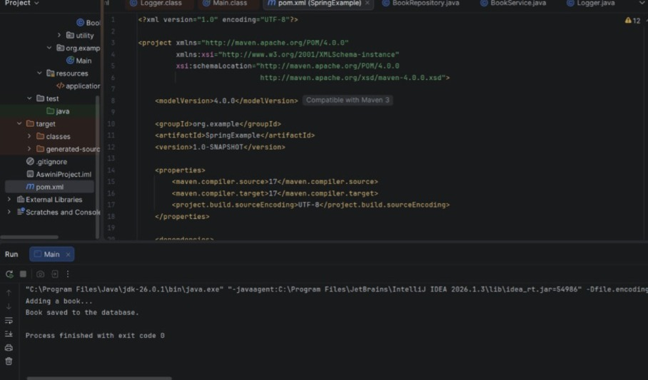

Exercise 7: Implementing Constructor and Setter Injection
Scenario:
The library management application requires both constructor and setter injection for better control over bean initialization.

BookRepository.java
package com.library.repository;

public class BookRepository {

public void saveBook() {
System.out.println("Book saved to the database.");
}
}

BookService.java

package com.library.service;

import com.library.repository.BookRepository;
import com.library.utility.Logger;

public class BookService {

private BookRepository bookRepository;
private Logger logger;

public BookService(Logger logger) {
this.logger = logger;
}

public void setBookRepository(BookRepository bookRepository) {
this.bookRepository = bookRepository;
}

public void addBook() {
logger.log("Adding a book...");
bookRepository.saveBook();
}
}

Logger.java
package com.library.utility;
public class Logger {
public void log(String message) {
System.out.println(message);
}
}

OUTPUT:
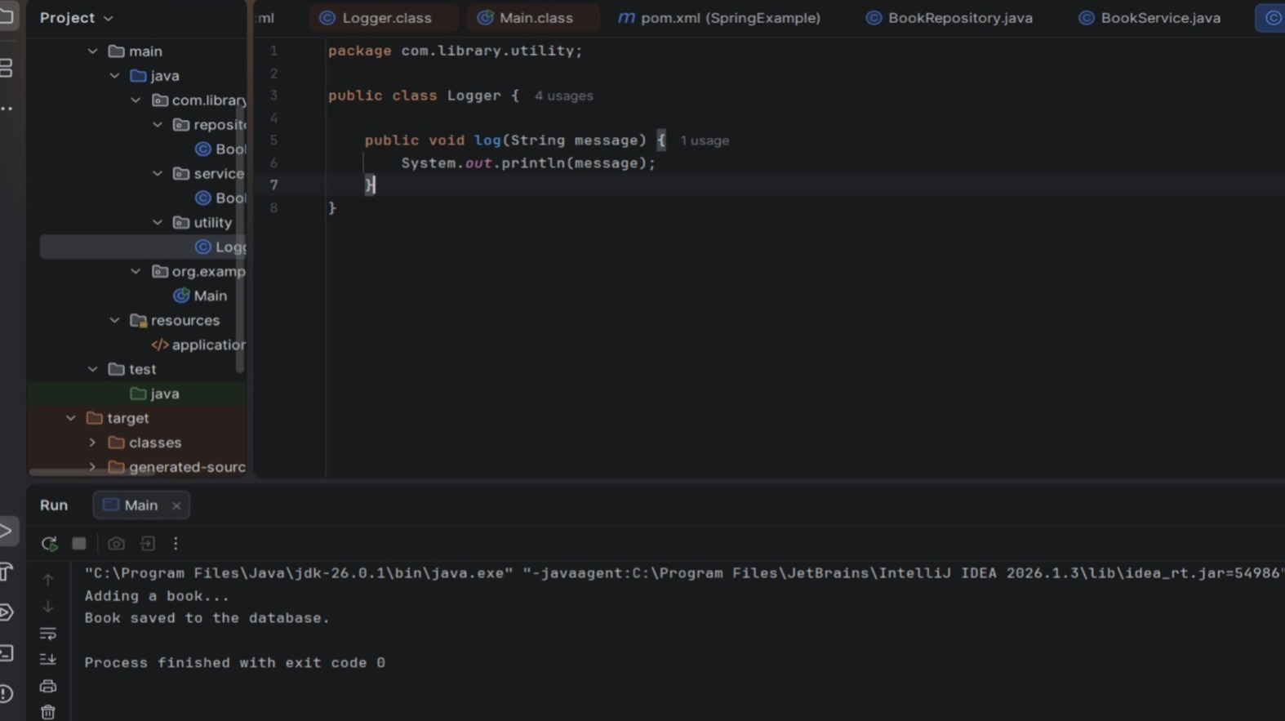
Exercise 9: Creating a Spring Boot Application
LibraryManagementApplication.java

package com.example.demo;
import org.springframework.boot.SpringApplication;
import org.springframework.boot.autoconfigure.SpringBootApplication;
import org.springframework.boot.autoconfigure.domain.
EntityScan;

Import org.springframework.data.jpa.repository.config.Enabl
eJpaRepositories;
import org.springframework.context.annotation.ComponentS
can;
@SpringBootApplication
@ComponentScan(basePackages = {"com.example"})
@EnableJpaRepositories(basePackages = "com.example.repository")
@EntityScan(basePackages = "com.example.model")
public class LibraryManagementApplication {
public static void main(String[] args) {
SpringApplication.run(LibraryManagementApplication.class, args);
}
}

Book.java
package com.example.model;
import jakarta.persistence.*;
@Entity
public class Book {
@Id
@GeneratedValue(strategy = GenerationType.IDENTITY)
private Long id;
private String title;
private String author;
private String isbn;
public Book() {}
public Book(String title, String author, String isbn) {
this.title = title;
this.author = author;
this.isbn = isbn;
}
public Long getId() { return id; }
public void setId(Long id) { this.id = id; }
public String getTitle() { return title; }
public void setTitle(String title) { this.title = title; }
public String getAuthor() { return author; }
public void setAuthor(String author) { this.author = author; }
public String getIsbn() { return isbn; }
public void setIsbn(String isbn) { this.isbn = isbn; }
}

BookController.java
import com.example.model.Book;
import com.example.repository.BookRepository;
import org.springframework.beans.factory.annotation.Autowired;
import org.springframework.web.bind.annotation.*;

import java.util.List;
import java.util.Optional;

@RestController
@RequestMapping("/books")
public class BookController {

@Autowired
private BookRepository bookRepository;

@PostMapping
public Book createBook(@RequestBody Book book) {
return bookRepository.save(book);
}

@GetMapping
public List<Book> getAllBooks() {
return bookRepository.findAll();
}

@GetMapping("/{id}")
public Book getBookById(@PathVariable Long id) {
return bookRepository.findById(id)
.orElseThrow(() -> new RuntimeException("Book not found with id: " + id));
}
@PutMapping("/{id}")
public Book updateBook(@PathVariable Long id, @RequestBody Book updatedBook) {
return bookRepository.findById(id)
.map(book -> {
book.setTitle(updatedBook.getTitle());
book.setAuthor(updatedBook.getAuthor());
book.setIsbn(updatedBook.getIsbn());
return bookRepository.save(book);
})
.orElseThrow(() -> new RuntimeException("Book not found with id: " + id));
}

@DeleteMapping("/{id}")
public String deleteBook(@PathVariable Long id) {
if (bookRepository.existsById(id)) {
bookRepository.deleteById(id);
return "Book deleted with id: " + id;
} else {
return "Book not found with id: " + id;
}
}
}
BookRepository.java
package com.example.repository;

import com.example.model.Book;
import org.springframework.data.jpa.repository.JpaRepository;

public interface BookRepository extends JpaRepository<Book, Long> {
}

OUTPUT:

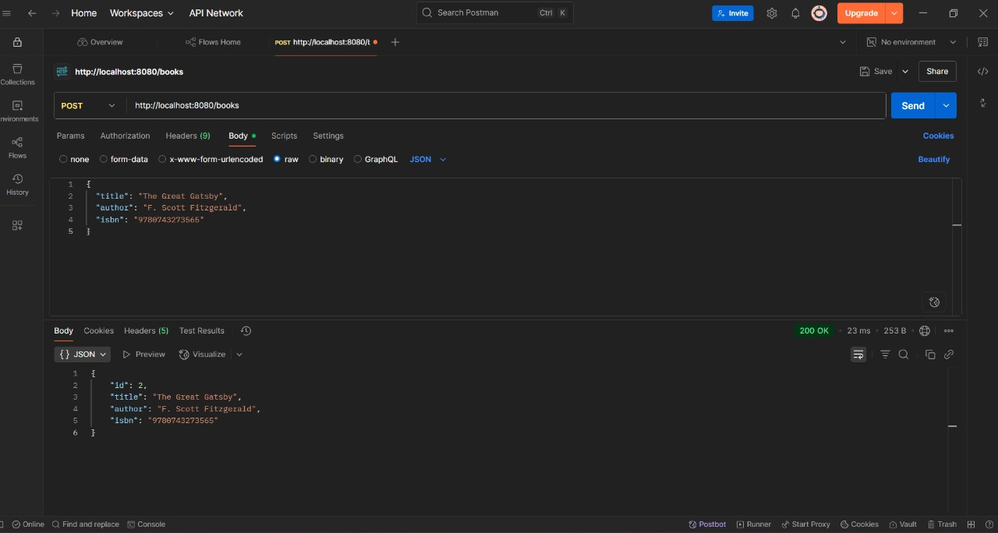
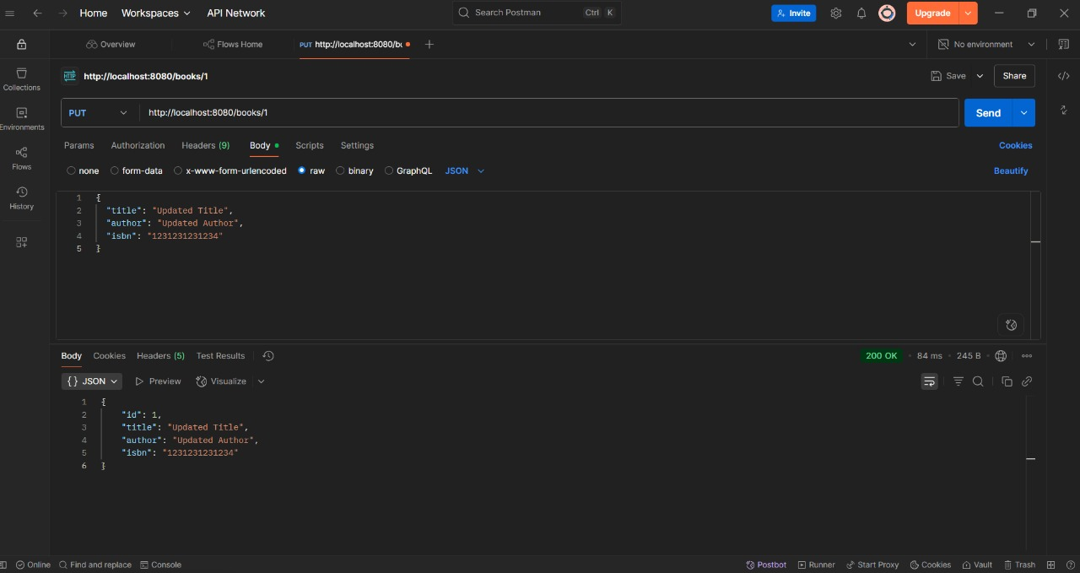

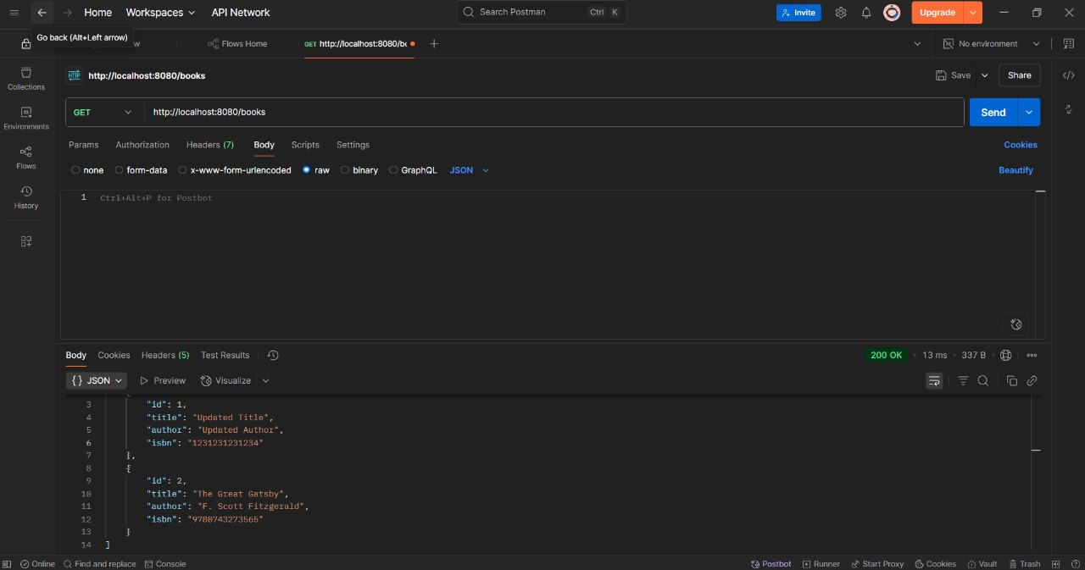
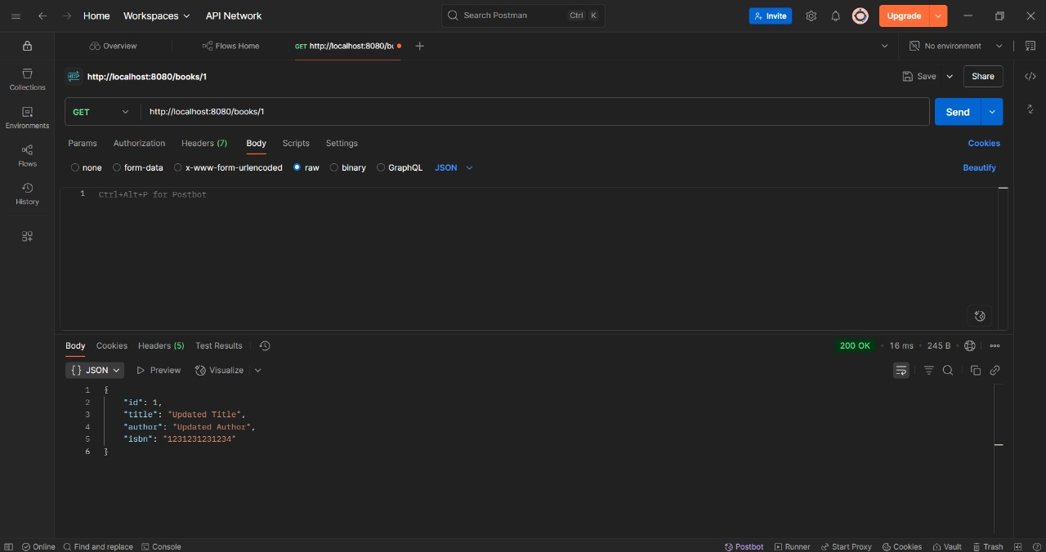

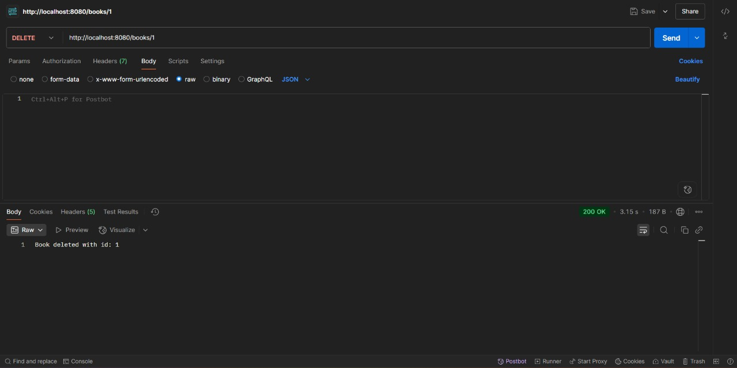

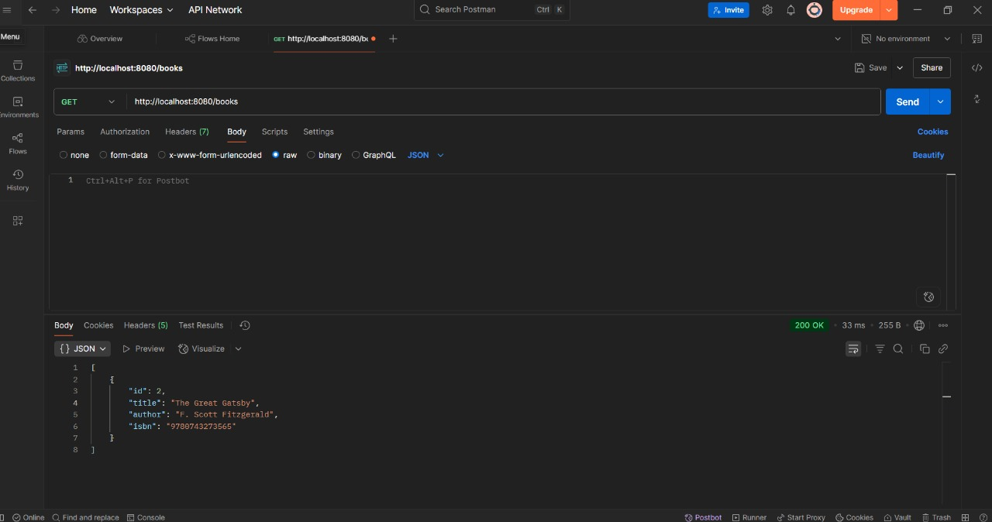

Spring Data JPA Hands-on Exercises:

Exercise 1: Spring Data JPA - Quick Example
Country.java
package com.cognizant.orm_learn.model;

import jakarta.persistence.Column;
import jakarta.persistence.Entity;
import jakarta.persistence.Id;
import jakarta.persistence.Table;

@Entity
@Table(name = "country")
public class Country {

@Id
@Column(name = "code")
private String code;

@Column(name = "name")
private String name;

public String getCode() {
return code;
}

public void setCode(String code) {
this.code = code;
}

public String getName() {
return name;
}

public void setName(String name) {
this.name = name;
}
@Override
public String toString() {
return "Country [code=" + code + ", name=" + name + "]";
}
}
CountryService.java
package com.cognizant.orm_learn.service;
import java.util.List;
import java.util.Optional;
import org.springframework.beans.factory.annotation.Autowired;
import org.springframework.stereotype.Service;

import com.cognizant.orm_learn.model.Country;
import com.cognizant.orm_learn.repository.CountryRepository;

import jakarta.transaction.Transactional;

@Service
public class CountryService {

@Autowired
private CountryRepository countryRepository;

@Transactional
public List<Country> getAllCountries() {
return countryRepository.findAll();
}

@Transactional
public void addCountry(Country country) {
if (!countryRepository.existsById(country.getCode())) {
countryRepository.save(country);
}
}

@Transactional
public Country findCountryByCode(String code) {
Optional<Country> result = countryRepository.findById(code);
return result.orElse(null);
}

@Transactional
public void deleteCountry(String code) {
countryRepository.deleteById(code);
}
}

CountryRepository.java
package com.cognizant.orm_learn.repository;
import org.springframework.data.jpa.repository.JpaRepository;
import org.springframework.stereotype.Repository;

import com.cognizant.orm_learn.model.Country;

@Repository
public interface CountryRepository extends JpaRepository<Country, String> {
}

OrmLearnApplication.java
package com.cognizant.orm_learn;
import com.cognizant.orm_learn.model.Country;
import com.cognizant.orm_learn.service.CountryService;
import java.util.List;
import org.slf4j.Logger;
import org.slf4j.LoggerFactory;
import org.springframework.boot.SpringApplication;
import org.springframework.boot.autoconfigure.SpringBootApplication;
import org.springframework.context.ApplicationContext;
@SpringBootApplication
public class OrmLearnApplication {
private static final Logger LOGGER = LoggerFactory.getLogger(OrmLearnApplication.class);
private static CountryService countryService;
public static void main(String[] args) {
ApplicationContext context = SpringApplication.run(OrmLearnApplication.class, args);
countryService = context.getBean(CountryService.class);
LOGGER.info("Inside main");

testGetAllCountries();
testAddCountry();
testFindCountryByCode();

testDeleteCountry();

testGetAllCountries();
}
private static void testGetAllCountries() {
LOGGER.info("Start");
List<Country> countries = countryService.getAllCountries();
LOGGER.debug("countries={}", countries);
LOGGER.info("End");
}
private static void testAddCountry() {
LOGGER.info("Start - Add Country");
Country country = new Country();
country.setCode("JP");
country.setName("Japan");
countryService.addCountry(country);
LOGGER.info("Added country: {}", country);
LOGGER.info("End");
}
private static void testFindCountryByCode() {
LOGGER.info("Start - Find Country");

Country country = countryService.findCountryByCode("JP");
LOGGER.info("Country found: {}", country);
LOGGER.info("End");
}
private static void testDeleteCountry() {
LOGGER.info("Start - Delete Country");
countryService.deleteCountry("JP");
LOGGER.info("Deleted country with code JP");
LOGGER.info("End");
}
}
Output:
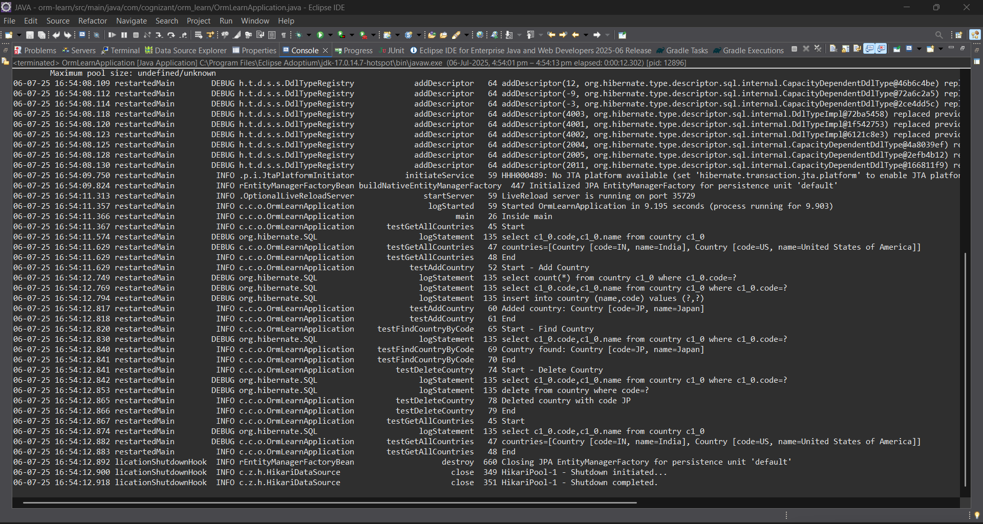

Exercise 4: Difference between JPA, Hibernate and Spring Data JPA
Employee.java
package com.cognizant.orm_learn.model;
import jakarta.persistence.*;
import java.util.Date;
import java.util.Set;
@Entity
@Table(name = "employee")
public class Employee {
@Id
@GeneratedValue(strategy = GenerationType.IDENTITY)
@Column(name = "em_id")
private int id;
@Column(name = "em_name")
private String name;
@Column(name = "em_salary")
private double salary;
@Column(name = "em_permanent")
private boolean permanent;
@Column(name = "em_date_of_birth")
private Date dateOfBirth;
@ManyToOne
@JoinColumn(name = "em_dp_id")
private Department department;
@ManyToMany(fetch = FetchType.EAGER)
@JoinTable(
name = "employee_skill",
joinColumns = @JoinColumn(name = "es_em_id"),
inverseJoinColumns = @JoinColumn(name = "es_sk_id")
)
private Set<Skill> skillList;
public int getId() { return id; }
public void setId(int id) { this.id = id; }
public String getName() { return name; }
public void setName(String name) { this.name = name; }
public double getSalary() { return salary; }
public void setSalary(double salary) { this.salary = salary; }
public boolean isPermanent() { return permanent; }
public void setPermanent(boolean permanent) { this.permanent = permanent; }
public Date getDateOfBirth() { return dateOfBirth; }
public void setDateOfBirth(Date dateOfBirth) { this.dateOfBirth = dateOfBirth; }
public Department getDepartment() { return department; }
public void setDepartment(Department department) { this.department = department; }
public Set<Skill> getSkillList() { return skillList; }
public void setSkillList(Set<Skill> skillList) { this.skillList = skillList; }
@Override
public String toString() {
return "Employee [id=" + id + ", name=" + name + ", salary=" + salary +
", permanent=" + permanent + ", dateOfBirth=" + dateOfBirth + "]";
}
}
Department.java
package com.cognizant.orm_learn.model;
import jakarta.persistence.*;
import java.util.Set;
@Entity
@Table(name = "department")
public class Department {
@Id
@GeneratedValue(strategy = GenerationType.IDENTITY)
@Column(name = "dp_id")
private int id;
@Column(name = "dp_name")
private String name;
@OneToMany(mappedBy = "department", fetch = FetchType.EAGER)
private Set<Employee> employeeList;
public int getId() {
return id;
}
public void setId(int id) {
this.id = id;
}
public String getName() {
return name;
}
public void setName(String name) {
this.name = name;
}
public Set<Employee> getEmployeeList() {
return employeeList;
}
public void setEmployeeList(Set<Employee> employeeList) {
this.employeeList = employeeList;
}
@Override
public String toString() {
return "Department [id=" + id + ", name=" + name + "]";
}
}
Skill.java
package com.cognizant.orm_learn.model;
import jakarta.persistence.*;
import java.util.Set;
@Entity
@Table(name = "skill")
public class Skill {
@Id
@GeneratedValue(strategy = GenerationType.IDENTITY)
@Column(name = "sk_id")
private int id;
@Column(name = "sk_name")
private String name;
@ManyToMany(mappedBy = "skillList")
private Set<Employee> employeeList;
public int getId() {
return id;
}
public void setId(int id) {
this.id = id;
}
public String getName() {
return name;
}
public void setName(String name) {
this.name = name;
}
public Set<Employee> getEmployeeList() {
return employeeList;
}
public void setEmployeeList(Set<Employee> employeeList) {
this.employeeList = employeeList;
}
@Override
public String toString() {
return "Skill [id=" + id + ", name=" + name + "]";
}
}
EmployeeRepository.java
package com.cognizant.orm_learn.repository;
import org.springframework.data.jpa.repository.JpaRepository;
import com.cognizant.orm_learn.model.Employee;
public interface EmployeeRepository extends JpaRepository<Employee, Integer> {}
DepartmentRepository.java
package com.cognizant.orm_learn.repository;
import org.springframework.data.jpa.repository.JpaRepository;
import com.cognizant.orm_learn.model.Department;
public interface DepartmentRepository extends JpaRepository<Department, Integer> {}
SkillRepository.java
package com.cognizant.orm_learn.repository;
import org.springframework.data.jpa.repository.JpaRepository;
import com.cognizant.orm_learn.model.Skill;
public interface SkillRepository extends JpaRepository<Skill, Integer> {}
EmployeeService.java
package com.cognizant.orm_learn.service;
import com.cognizant.orm_learn.model.Employee;
import com.cognizant.orm_learn.repository.EmployeeRepository;
import org.springframework.beans.factory.annotation.Autowired;
import org.springframework.stereotype.Service;
import jakarta.transaction.Transactional;
import org.slf4j.Logger;
import org.slf4j.LoggerFactory;
@Service
public class EmployeeService {
private static final Logger LOGGER = LoggerFactory.getLogger(EmployeeService.class);
@Autowired
private EmployeeRepository employeeRepository;
@Transactional
public Employee get(int id) {
LOGGER.info("Start");
return employeeRepository.findById(id).get();
}
@Transactional
public void save(Employee employee) {
LOGGER.info("Start");
employeeRepository.save(employee);
LOGGER.info("End");
}
}
DepartmentService.java
package com.cognizant.orm_learn.service;
import com.cognizant.orm_learn.model.Department;
import com.cognizant.orm_learn.repository.DepartmentRepository;
import org.springframework.beans.factory.annotation.Autowired;
import org.springframework.stereotype.Service;
import jakarta.transaction.Transactional;
@Service
public class DepartmentService {
@Autowired
private DepartmentRepository departmentRepository;
@Transactional
public Department get(int id) {
return departmentRepository.findById(id).get();
}
@Transactional
public void save(Department department) {
departmentRepository.save(department);
}
}
SkillService.java
package com.cognizant.orm_learn.service;
import com.cognizant.orm_learn.model.Skill;
import com.cognizant.orm_learn.repository.SkillRepository;
import org.springframework.beans.factory.annotation.Autowired;
import org.springframework.stereotype.Service;
import jakarta.transaction.Transactional;
@Service
public class SkillService {
@Autowired
private SkillRepository skillRepository;
@Transactional
public Skill get(int id) {
return skillRepository.findById(id).get();
}
@Transactional
public void save(Skill skill) {
skillRepository.save(skill);
}
}
OrmLearnApplication.java
package com.cognizant.orm_learn;
import com.cognizant.orm_learn.model.Department;
import com.cognizant.orm_learn.model.Employee;
import com.cognizant.orm_learn.model.Skill;
import com.cognizant.orm_learn.service.DepartmentService;
import com.cognizant.orm_learn.service.EmployeeService;
import com.cognizant.orm_learn.service.SkillService;
import org.slf4j.Logger;
import org.slf4j.LoggerFactory;
import org.springframework.boot.SpringApplication;
import org.springframework.boot.autoconfigure.SpringBootApplication;
import org.springframework.context.ApplicationContext;
import java.util.Date;
import java.util.HashSet;
import java.util.Set;
@SpringBootApplication
public class OrmLearnApplication {
private static final Logger LOGGER = LoggerFactory.getLogger(OrmLearnApplication.class);
private static EmployeeService employeeService;
private static DepartmentService departmentService;
private static SkillService skillService;
public static void main(String[] args) {
ApplicationContext context = SpringApplication.run(OrmLearnApplication.class, args);
employeeService = context.getBean(EmployeeService.class);
departmentService = context.getBean(DepartmentService.class);
skillService = context.getBean(SkillService.class);
LOGGER.info("Inside main");
testAddEmployee();
testUpdateEmployee();
testGetDepartment();
testAddSkillToEmployee();
}
private static void testAddEmployee() {
LOGGER.info("Start - testAddEmployee");

Employee employee = new Employee();
employee.setName("Jane Doe");
employee.setSalary(60000.0);
employee.setPermanent(true);
employee.setDateOfBirth(new Date());
Department department = departmentService.get(1);
Set<Skill> skillList = new HashSet<>();
skillList.add(skillService.get(1));
skillList.add(skillService.get(2));
employee.setSkillList(skillList);
employeeService.save(employee);
LOGGER.debug("Employee added: {}", employee);
LOGGER.info("End");
}

private static void testGetEmployee() {
LOGGER.info("Start - testGetEmployee");
Employee employee = employeeService.get(1); // use valid employee id
LOGGER.debug("Employee: {}", employee);
LOGGER.debug("Department: {}", employee.getDepartment());
LOGGER.debug("Skills: {}", employee.getSkillList());
LOGGER.info("End");
}
private static void testUpdateEmployee() {
LOGGER.info("Start - testUpdateEmployee");
Employee employee = employeeService.get(1); // use valid employee id
Department newDept = departmentService.get(2); // different department ID
employee.setDepartment(newDept);
employeeService.save(employee);
LOGGER.debug("Updated Employee: {}", employee);
LOGGER.info("End");
}
private static void testGetDepartment() {
LOGGER.info("Start - testGetDepartment");
Department department = departmentService.get(1); // department with multiple employees
LOGGER.debug("Department: {}", department);
LOGGER.debug("Employees: {}", department.getEmployeeList());
LOGGER.info("End");
}
private static void testAddSkillToEmployee() {
LOGGER.info("Start - testAddSkillToEmployee");
Employee employee = employeeService.get(1); // valid employee id
Skill skill = skillService.get(2); // valid skill id not already assigned
Set<Skill> skillList = employee.getSkillList();
if (skillList == null) {
skillList = new HashSet<>();
}
skillList.add(skill);
employee.setSkillList(skillList);
employeeService.save(employee);
LOGGER.debug("Updated Employee with new skill: {}", employee);
LOGGER.info("End");
}
}
Output:

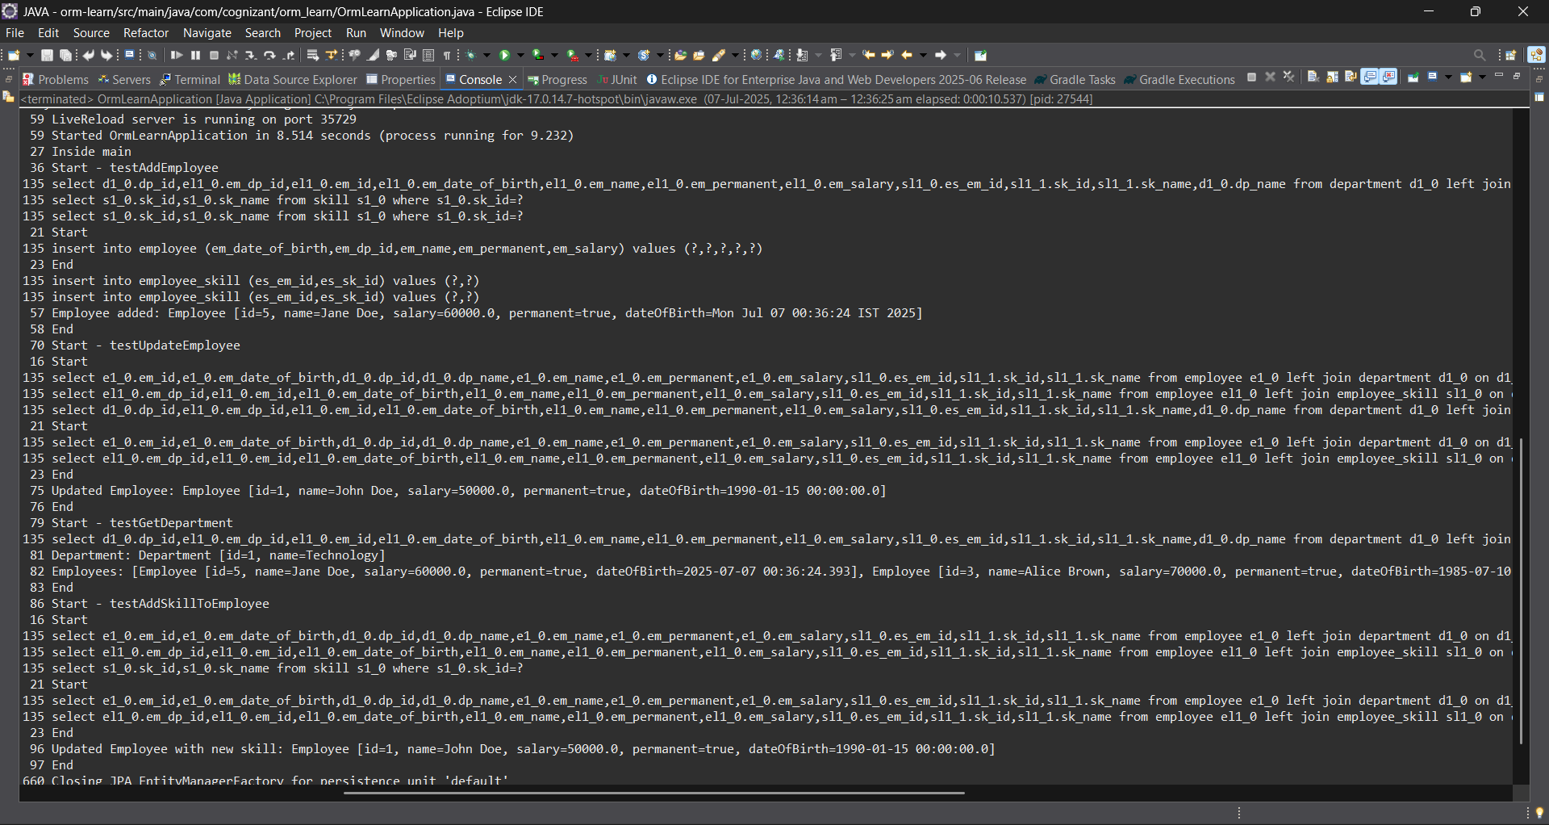

Exercise 5: Implement services for managing Country

package com.cognizant.orm_learn.model;

import jakarta.persistence.Column;
import jakarta.persistence.Entity;
import jakarta.persistence.Id;
import jakarta.persistence.Table;

@Entity
@Table(name = "country")
public class Country {

@Id
@Column(name = "code")
private String code;

@Column(name = "name")
private String name;

public String getCode() {
return code;
}

public void setCode(String code) {
this.code = code;
}

public String getName() {
return name;
}

public void setName(String name) {
this.name = name;
}

@Override
public String toString() {
return "Country [code=" + code + ", name=" + name + "]";
}
}

CountryService.java
package com.cognizant.orm_learn.service;
import com.cognizant.orm_learn.model.Country;
import java.util.List;
public interface CountryService {
Country findCountryByCode(String code);
void addCountry(Country country);
void updateCountry(Country country);
void deleteCountry(String code);

List<Country> findCountriesByPartialName(String name);
List<Country> getAllCountries();
}

CountryServiceImpl.java
package com.cognizant.orm_learn.service;
import com.cognizant.orm_learn.model.Country;
import com.cognizant.orm_learn.repository.CountryRepository;
import jakarta.transaction.Transactional;
import org.springframework.beans.factory.annotation.Autowired;
import org.springframework.stereotype.Service;
import java.util.List;
@Service
@Transactional
public class CountryServiceImpl implements CountryService {
@Autowired
private CountryRepository countryRepository;
@Override
public Country findCountryByCode(String code) {
return countryRepository.findById(code).orElse(null);
}
@Override
public void addCountry(Country country) {
countryRepository.save(country);
}
@Override
public void updateCountry(Country country) {
Country existing = countryRepository.findById(country.getCode()).orElse(null);
if (existing != null) {
existing.setName(country.getName());
countryRepository.save(existing);
}
}
@Override
public void deleteCountry(String code) {
countryRepository.deleteById(code);
}
@Override
public List<Country> findCountriesByPartialName(String name) {
return countryRepository.findByNameContainingIgnoreCase(name);
}
@Override
public List<Country> getAllCountries() {
return countryRepository.findAll();
}
}

OrmLearnApplication.java

package com.cognizant.orm_learn;
import com.cognizant.orm_learn.model.Country;
import com.cognizant.orm_learn.service.CountryService;
import java.util.List;
import org.slf4j.Logger;
import org.slf4j.LoggerFactory;
import org.springframework.boot.SpringApplication;
import org.springframework.boot.autoconfigure.SpringBootApplication;
import org.springframework.context.ApplicationContext;
@SpringBootApplication
public class OrmLearnApplication {
private static final Logger LOGGER = LoggerFactory.getLogger(OrmLearnApplication.class);
private static CountryService countryService;
public static void main(String[] args) {
ApplicationContext context = SpringApplication.run(OrmLearnApplication.class, args);
countryService = context.getBean(CountryService.class);
LOGGER.info("Inside main");
testGetAllCountries();
testAddCountry();

testFindCountryByCode();

testDeleteCountry();
testGetAllCountries();
testFindCountriesByPartialName();
}
private static void testGetAllCountries() {
LOGGER.info("Start - Get All Countries");
List<Country> countries = countryService.getAllCountries();
LOGGER.debug("countries={}", countries);
LOGGER.info("End");
}
private static void testAddCountry() {
LOGGER.info("Start - Add Country");
Country country = new Country();
country.setCode("JP");
country.setName("Japan");

countryService.addCountry(country);
LOGGER.info("Added country: {}", country);
LOGGER.info("End");
}
private static void testFindCountryByCode() {
LOGGER.info("Start - Find Country by Code");
Country country = countryService.findCountryByCode("JP");
LOGGER.info("Country found: {}", country);
LOGGER.info("End");
}
private static void testDeleteCountry() {
LOGGER.info("Start - Delete Country");
countryService.deleteCountry("JP");
LOGGER.info("Deleted country with code JP");
LOGGER.info("End");
}
private static void testFindCountriesByPartialName() {
LOGGER.info("Start - Find Countries by Partial Name");
String partialName = "Uni"; // Example input
List<Country> countries = countryService.findCountriesByPartialName(partialName);
LOGGER.info("Countries matching '{}': {}", partialName, countries);
LOGGER.info("End");
}
}

Output:

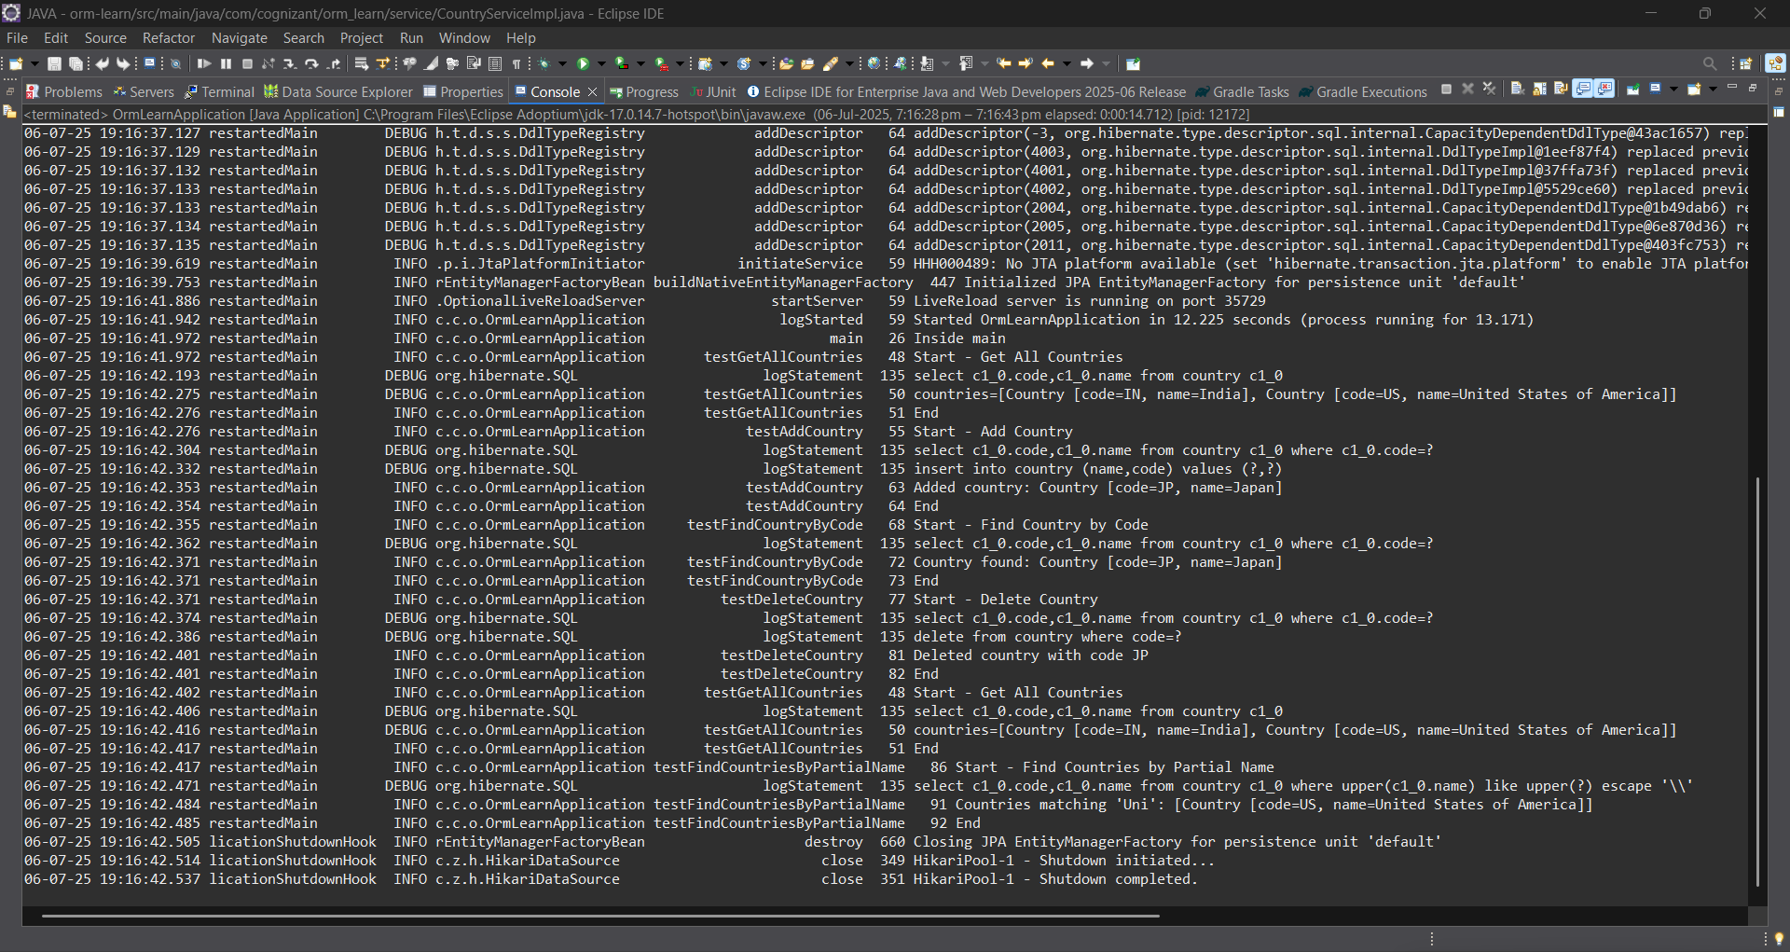

Exercise 4: Difference between JPA, Hibernate and Spring Data JPA
Employee.java
package com.cognizant.orm_learn.model;
import jakarta.persistence.*;
import java.util.Date;
import java.util.Set;
@Entity
@Table(name = "employee")
public class Employee {
@Id
@GeneratedValue(strategy = GenerationType.IDENTITY)
@Column(name = "em_id")
private int id;
@Column(name = "em_name")
private String name;
@Column(name = "em_salary")
private double salary;
@Column(name = "em_permanent")
private boolean permanent;
@Column(name = "em_date_of_birth")
private Date dateOfBirth;
@ManyToOne
@JoinColumn(name = "em_dp_id")
private Department department;
@ManyToMany(fetch = FetchType.EAGER)
@JoinTable(
name = "employee_skill",
joinColumns = @JoinColumn(name = "es_em_id"),
inverseJoinColumns = @JoinColumn(name = "es_sk_id")
)
private Set<Skill> skillList;
public int getId() { return id; }
public void setId(int id) { this.id = id; }
public String getName() { return name; }
public void setName(String name) { this.name = name; }
public double getSalary() { return salary; }
public void setSalary(double salary) { this.salary = salary; }
public boolean isPermanent() { return permanent; }
public void setPermanent(boolean permanent) { this.permanent = permanent; }
public Date getDateOfBirth() { return dateOfBirth; }
public void setDateOfBirth(Date dateOfBirth) { this.dateOfBirth = dateOfBirth; }
public Department getDepartment() { return department; }
public void setDepartment(Department department) { this.department = department; }
public Set<Skill> getSkillList() { return skillList; }
public void setSkillList(Set<Skill> skillList) { this.skillList = skillList; }
@Override
public String toString() {
return "Employee [id=" + id + ", name=" + name + ", salary=" + salary +
", permanent=" + permanent + ", dateOfBirth=" + dateOfBirth + "]";
}
}
Department.java

package com.cognizant.orm_learn.model;
import jakarta.persistence.*;
import java.util.Set;
@Entity
@Table(name = "department")
public class Department {
@Id
@GeneratedValue(strategy = GenerationType.IDENTITY)
@Column(name = "dp_id")
private int id;
@Column(name = "dp_name")
private String name;
@OneToMany(mappedBy = "department", fetch = FetchType.EAGER)
private Set<Employee> employeeList;
public int getId() {
return id;
}
public void setId(int id) {
this.id = id;
}
public String getName() {
return name;
}
public void setName(String name) {
this.name = name;
}
public Set<Employee> getEmployeeList() {
return employeeList;
}
public void setEmployeeList(Set<Employee> employeeList) {
this.employeeList = employeeList;
}
@Override
public String toString() {
return "Department [id=" + id + ", name=" + name + "]";camera’ca
}
}
Skill.java
package com.cognizant.orm_learn.model;
import jakarta.persistence.*;
import java.util.Set;
@Entity
@Table(name = "skill")
public class Skill {
@Id
@GeneratedValue(strategy = GenerationType.IDENTITY)
@Column(name = "sk_id")
private int id;
@Column(name = "sk_name")
private String name;
@ManyToMany(mappedBy = "skillList")
private Set<Employee> employeeList;
public int getId() {
return id;
}
public void setId(int id) {
this.id = id;
}
public String getName() {
return name;
}
public void setName(String name) {
this.name = name;
}
public Set<Employee> getEmployeeList() {
return employeeList;
}
public void setEmployeeList(Set<Employee> employeeList) {
this.employeeList = employeeList;
}
@Override
public String toString() {
return "Skill [id=" + id + ", name=" + name + "]";
}
}
EmployeeRepository.java
package com.cognizant.orm_learn.repository;
import org.springframework.data.jpa.repository.JpaRepository;
import com.cognizant.orm_learn.model.Employee;
public interface EmployeeRepository extends JpaRepository<Employee, Integer> {}
DepartmentRepository.java
package com.cognizant.orm_learn.repository;
import org.springframework.data.jpa.repository.JpaRepository;
import com.cognizant.orm_learn.model.Department;
public interface DepartmentRepository extends JpaRepository<Department, Integer> {}
SkillRepository.java
package com.cognizant.orm_learn.repository;
import org.springframework.data.jpa.repository.JpaRepository;
import com.cognizant.orm_learn.model.Skill;
public interface SkillRepository extends JpaRepository<Skill, Integer> {}
EmployeeService.java
package com.cognizant.orm_learn.service;
import com.cognizant.orm_learn.model.Employee;
import com.cognizant.orm_learn.repository.EmployeeRepository;
import org.springframework.beans.factory.annotation.Autowired;
import org.springframework.stereotype.Service;
import jakarta.transaction.Transactional;
import org.slf4j.Logger;
import org.slf4j.LoggerFactory;
@Service
public class EmployeeService {
private static final Logger LOGGER = LoggerFactory.getLogger(EmployeeService.class);
@Autowired
private EmployeeRepository employeeRepository;
@Transactional
public Employee get(int id) {
LOGGER.info("Start");
return employeeRepository.findById(id).get();
}
@Transactional
public void save(Employee employee) {
LOGGER.info("Start");
employeeRepository.save(employee);
LOGGER.info("End");
}
}
DepartmentService.java
package com.cognizant.orm_learn.service;
import com.cognizant.orm_learn.model.Department;
import com.cognizant.orm_learn.repository.DepartmentRepository;
import org.springframework.beans.factory.annotation.Autowired;
import org.springframework.stereotype.Service;
import jakarta.transaction.Transactional;
@Service
public class DepartmentService {
@Autowired
private DepartmentRepository departmentRepository;
@Transactional
public Department get(int id) {
return departmentRepository.findById(id).get();
}
@Transactional
public void save(Department department) {
departmentRepository.save(department);
}
}
SkillService.java
package com.cognizant.orm_learn.service;
import com.cognizant.orm_learn.model.Skill;
import com.cognizant.orm_learn.repository.SkillRepository;
import org.springframework.beans.factory.annotation.Autowired;
import org.springframework.stereotype.Service;
import jakarta.transaction.Transactional;
@Service
public class SkillService {
@Autowired
private SkillRepository skillRepository;
@Transactional
public Skill get(int id) {
return skillRepository.findById(id).get();
}
@Transactional
public void save(Skill skill) {
skillRepository.save(skill);
}
}
OrmLearnApplication.java
package com.cognizant.orm_learn;
import com.cognizant.orm_learn.model.Department;
import com.cognizant.orm_learn.model.Employee;
import com.cognizant.orm_learn.model.Skill;
import com.cognizant.orm_learn.service.DepartmentService;
import com.cognizant.orm_learn.service.EmployeeService;
import com.cognizant.orm_learn.service.SkillService;
import org.slf4j.Logger;
import org.slf4j.LoggerFactory;
import org.springframework.boot.SpringApplication;
import org.springframework.boot.autoconfigure.SpringBootApplication;
import org.springframework.context.ApplicationContext;
import java.util.Date;
import java.util.HashSet;
import java.util.Set;
@SpringBootApplication
public class OrmLearnApplication {
private static final Logger LOGGER = LoggerFactory.getLogger(OrmLearnApplication.class);
private static EmployeeService employeeService;
private static DepartmentService departmentService;
private static SkillService skillService;
public static void main(String[] args) {
ApplicationContext context = SpringApplication.run(OrmLearnApplication.class, args);
employeeService = context.getBean(EmployeeService.class);
departmentService = context.getBean(DepartmentService.class);
skillService = context.getBean(SkillService.class);
LOGGER.info("Inside main");
// Uncomment the methods below one by one to test
testAddEmployee();
//testGetEmployee();
testUpdateEmployee();
testGetDepartment();
testAddSkillToEmployee();
}
private static void testAddEmployee() {
LOGGER.info("Start - testAddEmployee");

Employee employee = new Employee();
employee.setName("Jane Doe");
employee.setSalary(60000.0);
employee.setPermanent(true);
employee.setDateOfBirth(new Date());

Department department = departmentService.get(1);
employee.setDepartment(department);

Set<Skill> skillList = new HashSet<>();
skillList.add(skillService.get(1));
skillList.add(skillService.get(2));
employee.setSkillList(skillList);

employeeService.save(employee);

LOGGER.debug("Employee added: {}", employee);
LOGGER.info("End");
}

private static void testGetEmployee() {
LOGGER.info("Start - testGetEmployee");
Employee employee = employeeService.get(1);
LOGGER.debug("Employee: {}", employee);
LOGGER.debug("Department: {}", employee.getDepartment());
LOGGER.debug("Skills: {}", employee.getSkillList());
LOGGER.info("End");
}
private static void testUpdateEmployee() {
LOGGER.info("Start - testUpdateEmployee");
Employee employee = employeeService.get(1);
Department newDept = departmentService.get(2);
employee.setDepartment(newDept);
employeeService.save(employee);
LOGGER.debug("Updated Employee: {}", employee);
LOGGER.info("End");
}
private static void testGetDepartment() {
LOGGER.info("Start - testGetDepartment");
Department department = departmentService.get(1);
LOGGER.debug("Department: {}", department);
LOGGER.debug("Employees: {}", department.getEmployeeList());
LOGGER.info("End");
}
private static void testAddSkillToEmployee() {
LOGGER.info("Start - testAddSkillToEmployee");
Employee employee = employeeService.get(1);
Skill skill = skillService.get(2);
Set<Skill> skillList = employee.getSkillList();
if (skillList == null) {
skillList = new HashSet<>();
}
skillList.add(skill);
employee.setSkillList(skillList);
employeeService.save(employee);
LOGGER.debug("Updated Employee with new skill: {}", employee);
LOGGER.info("End");
}
}
Output:


Exercise 5: Implement services for managing Country
Country.java:
package com.cognizant.orm_learn.model;

import jakarta.persistence.Column;
import jakarta.persistence.Entity;
import jakarta.persistence.Id;
import jakarta.persistence.Table;

@Entity
@Table(name = "country")
public class Country {

@Id
@Column(name = "code")
private String code;

@Column(name = "name")
private String name;

public String getCode() {
return code;
}

public void setCode(String code) {
this.code = code;
}

public String getName() {
return name;
}

public void setName(String name) {
this.name = name;
}

@Override
public String toString() {
return "Country [code=" + code + ", name=" + name + "]";
}
}

CountryService.java
package com.cognizant.orm_learn.service;
import com.cognizant.orm_learn.model.Country;
import java.util.List;
public interface CountryService {
Country findCountryByCode(String code);
void addCountry(Country country);
void updateCountry(Country country);
void deleteCountry(String code);

List<Country> findCountriesByPartialName(String name);
List<Country> getAllCountries();
}

CountryServiceImpl.java
package com.cognizant.orm_learn.service;
import com.cognizant.orm_learn.model.Country;
import com.cognizant.orm_learn.repository.CountryRepository;
import jakarta.transaction.Transactional;
import org.springframework.beans.factory.annotation.Autowired;
import org.springframework.stereotype.Service;
import java.util.List;
@Service
@Transactional
public class CountryServiceImpl implements CountryService {
@Autowired
private CountryRepository countryRepository;
@Override
public Country findCountryByCode(String code) {
return countryRepository.findById(code).orElse(null);
}
@Override
public void addCountry(Country country) {
countryRepository.save(country);
}
@Override
public void updateCountry(Country country) {
Country existing = countryRepository.findById(country.getCode()).orElse(null);
if (existing != null) {
existing.setName(country.getName());
countryRepository.save(existing);
}
}
@Override
public void deleteCountry(String code) {
countryRepository.deleteById(code);
}
@Override
public List<Country> findCountriesByPartialName(String name) {
return countryRepository.findByNameContainingIgnoreCase(name);
}
@Override
public List<Country> getAllCountries() {
return countryRepository.findAll();
}
}

OrmLearnApplication.java
package com.cognizant.orm_learn;
import com.cognizant.orm_learn.model.Country;
import com.cognizant.orm_learn.service.CountryService;
import java.util.List;
import org.slf4j.Logger;
import org.slf4j.LoggerFactory;
import org.springframework.boot.SpringApplication;
import org.springframework.boot.autoconfigure.SpringBootApplication;
import org.springframework.context.ApplicationContext;
@SpringBootApplication
public class OrmLearnApplication {
private static final Logger LOGGER = LoggerFactory.getLogger(OrmLearnApplication.class);
private static CountryService countryService;
public static void main(String[] args) {
ApplicationContext context = SpringApplication.run(OrmLearnApplication.class, args);
countryService = context.getBean(CountryService.class);
LOGGER.info("Inside main");
// 1. Fetch all countries
testGetAllCountries();
// 2. Add a new country
testAddCountry();
// 3. Find a country by code
testFindCountryByCode();
// 4. Delete a country
testDeleteCountry();
// 5. Final country list
testGetAllCountries();
// 6. Find countries by partial name
testFindCountriesByPartialName();
}
private static void testGetAllCountries() {
LOGGER.info("Start - Get All Countries");
List<Country> countries = countryService.getAllCountries();
LOGGER.debug("countries={}", countries);
LOGGER.info("End");
}
private static void testAddCountry() {
LOGGER.info("Start - Add Country");
Country country = new Country();
country.setCode("JP");
country.setName("Japan");

countryService.addCountry(country);
LOGGER.info("Added country: {}", country);
LOGGER.info("End");
}
private static void testFindCountryByCode() {
LOGGER.info("Start - Find Country by Code");
Country country = countryService.findCountryByCode("JP");
LOGGER.info("Country found: {}", country);
LOGGER.info("End");
}
private static void testDeleteCountry() {
LOGGER.info("Start - Delete Country");
countryService.deleteCountry("JP");
LOGGER.info("Deleted country with code JP");
LOGGER.info("End");
}
private static void testFindCountriesByPartialName() {
LOGGER.info("Start - Find Countries by Partial Name");
String partialName = "Uni"; // Example input
List<Country> countries = countryService.findCountriesByPartialName(partialName);
LOGGER.info("Countries matching '{}': {}", partialName, countries);
LOGGER.info("End");
}
}

Output:


Exercise 6: Find a country based on country code
CountryService.java
package com.cognizant.orm_learn.service;
import com.cognizant.orm_learn.model.Country;
import com.cognizant.orm_learn.service.exception.CountryNotFoundException;
import java.util.List;
import jakarta.transaction.Transactional;
public interface CountryService {
@Transactional
Country findCountryByCode(String code) throws CountryNotFoundException;
void addCountry(Country country);
void updateCountry(Country country);
void deleteCountry(String code);
List<Country> findCountriesByPartialName(String name);
List<Country> getAllCountries();
}

CountryServiceImpl.java

package com.cognizant.orm_learn.service;
import com.cognizant.orm_learn.model.Country;
import com.cognizant.orm_learn.repository.CountryRepository;
import com.cognizant.orm_learn.service.exception.CountryNotFoundException;
import jakarta.transaction.Transactional;
import org.springframework.beans.factory.annotation.Autowired;
import org.springframework.stereotype.Service;
import java.util.List;
import java.util.Optional;
@Service
@Transactional
public class CountryServiceImpl implements CountryService {
@Autowired
private CountryRepository countryRepository;
@Override
public Country findCountryByCode(String code) throws CountryNotFoundException {
Optional<Country> result = countryRepository.findById(code);
if (!result.isPresent()) {
throw new CountryNotFoundException("Country not found with code: " + code);
}
return result.get();
}
@Override
public void addCountry(Country country) {
countryRepository.save(country);
}
@Override
public void updateCountry(Country country) {
Country existing = countryRepository.findById(country.getCode()).orElse(null);
if (existing != null) {
existing.setName(country.getName());
countryRepository.save(existing);
}
}
@Override
public void deleteCountry(String code) {
countryRepository.deleteById(code);
}
@Override
public List<Country> findCountriesByPartialName(String name) {
return countryRepository.findByNameContainingIgnoreCase(name);
}
@Override
public List<Country> getAllCountries() {
return countryRepository.findAll();
}
}

OrmLearnApplication.java
package com.cognizant.orm_learn;
import com.cognizant.orm_learn.model.Country;
import com.cognizant.orm_learn.service.CountryService;
import com.cognizant.orm_learn.service.exception.CountryNotFoundException;
import java.util.List;
import org.slf4j.Logger;
import org.slf4j.LoggerFactory;
import org.springframework.boot.SpringApplication;
import org.springframework.boot.autoconfigure.SpringBootApplication;
import org.springframework.context.ApplicationContext;
@SpringBootApplication
public class OrmLearnApplication {
private static final Logger LOGGER = LoggerFactory.getLogger(OrmLearnApplication.class);
private static CountryService countryService;
public static void main(String[] args) {
ApplicationContext context = SpringApplication.run(OrmLearnApplication.class, args);
countryService = context.getBean(CountryService.class);
LOGGER.info("Inside main");

testGetAllCountries();
testAddCountry();
testFindCountryByCode();
testDeleteCountry();
testGetAllCountries();

testFindCountriesByPartialName();
}
private static void testGetAllCountries() {
LOGGER.info("Start - Get All Countries");
List<Country> countries = countryService.getAllCountries();
LOGGER.debug("countries={}", countries);
LOGGER.info("End");
}
private static void testAddCountry() {
LOGGER.info("Start - Add Country");
Country country = new Country();
country.setCode("JP");
country.setName("Japan");
countryService.addCountry(country);
LOGGER.info("Added country: {}", country);
LOGGER.info("End");
}
private static void testFindCountryByCode() {
LOGGER.info("Start - Find Country by Code");
try {
Country country = countryService.findCountryByCode("IN"); // Change "IN" to "JP" or other
LOGGER.info("Country found: {}", country);
} catch (CountryNotFoundException e) {
LOGGER.error("Exception: {}", e.getMessage());
}
LOGGER.info("End");
}
private static void testDeleteCountry() {
LOGGER.info("Start - Delete Country");
countryService.deleteCountry("JP");
LOGGER.info("Deleted country with code JP");
LOGGER.info("End");
}
private static void testFindCountriesByPartialName() {
LOGGER.info("Start - Find Countries by Partial Name");
String partialName = "Uni"; // Example input
List<Country> countries = countryService.findCountriesByPartialName(partialName);
LOGGER.info("Countries matching '{}': {}", partialName, countries);
LOGGER.info("End");
}
}

CountryNotFoundException.java
package com.cognizant.orm_learn.service.exception;

public class CountryNotFoundException extends Exception {
public CountryNotFoundException(String message) {
super(message);
}
}

Output:
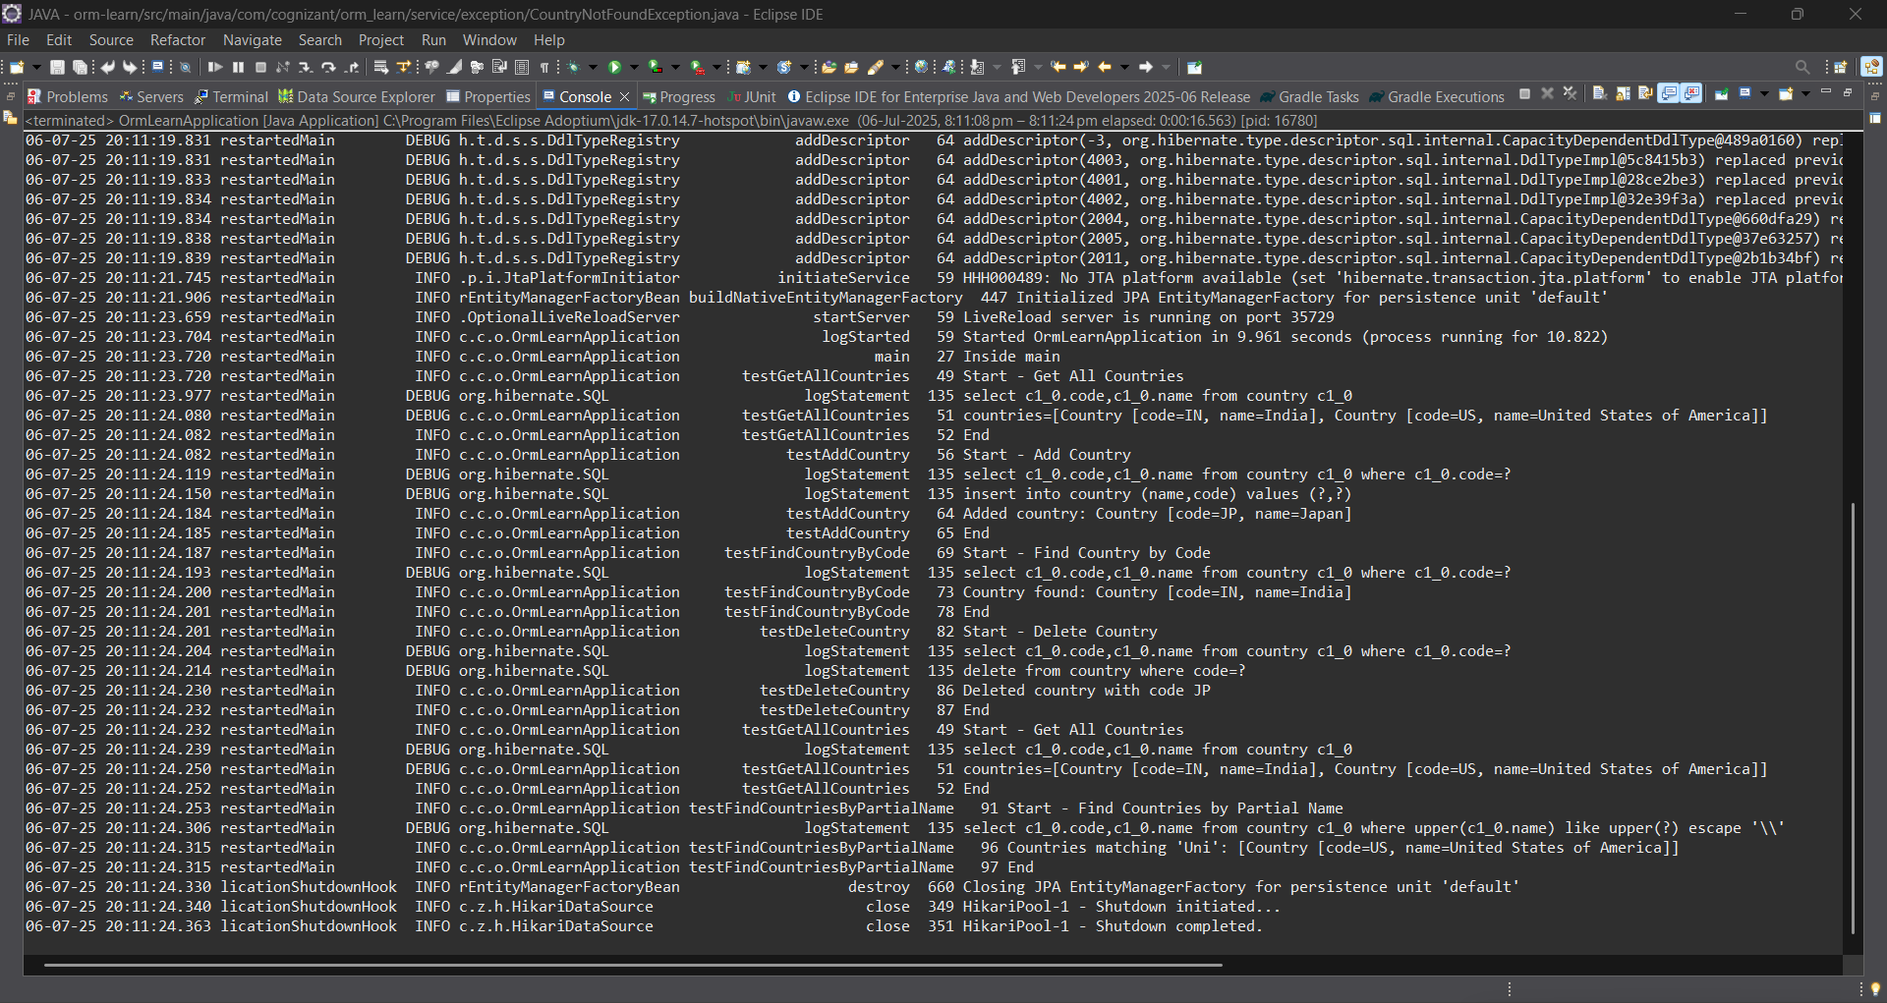

Exercise 7: Add a new country
OrmLearnApplication.java
package com.cognizant.orm_learn;
import com.cognizant.orm_learn.model.Country;
import com.cognizant.orm_learn.service.CountryService;
import com.cognizant.orm_learn.service.exception.CountryNotFoundException;
import java.util.List;
import org.slf4j.Logger;
import org.slf4j.LoggerFactory;
import org.springframework.boot.SpringApplication;
import org.springframework.boot.autoconfigure.SpringBootApplication;
import org.springframework.context.ApplicationContext;
@SpringBootApplication
public class OrmLearnApplication {
private static final Logger LOGGER = LoggerFactory.getLogger(OrmLearnApplication.class);
private static CountryService countryService;
public static void main(String[] args) {
ApplicationContext context = SpringApplication.run(OrmLearnApplication.class, args);
countryService = context.getBean(CountryService.class);
LOGGER.info("Inside main");

testGetAllCountries();
testAddCountry();

testFindCountryByCode();
testDeleteCountry();
testGetAllCountries();
testFindCountriesByPartialName();}
private static void testGetAllCountries() {
LOGGER.info("Start - Get All Countries");
List<Country> countries = countryService.getAllCountries();
LOGGER.debug("countries={}", countries);
LOGGER.info("End");
}
private static void testFindCountryByCode() {
LOGGER.info("Start - Find Country by Code");
try {
Country country = countryService.findCountryByCode("IN"); // Change "IN" to "JP" or other
LOGGER.info("Country found: {}", country);
} catch (CountryNotFoundException e) {
LOGGER.error("Exception: {}", e.getMessage());
}
LOGGER.info("End");
}
private static void testDeleteCountry() {
LOGGER.info("Start - Delete Country");
countryService.deleteCountry("JP");
LOGGER.info("Deleted country with code JP");
LOGGER.info("End");
}
private static void testFindCountriesByPartialName() {
LOGGER.info("Start - Find Countries by Partial Name");
String partialName = "Uni"; // Example input
List<Country> countries = countryService.findCountriesByPartialName(partialName);
LOGGER.info("Countries matching '{}': {}", partialName, countries);
LOGGER.info("End");
}
private static void testAddCountry() {
LOGGER.info("Start - Add Country");
Country country = new Country();
country.setCode("FR"); // Use a new unique code
country.setName("France");
countryService.addCountry(country);
LOGGER.info("Added country: {}", country);
try {
Country retrieved = countryService.findCountryByCode("FR");
LOGGER.info("Country fetched from DB: {}", retrieved);
} catch (Exception e) {
LOGGER.error("Country not found after adding: {}", e.getMessage());
}
LOGGER.info("End");
}
}
Output:
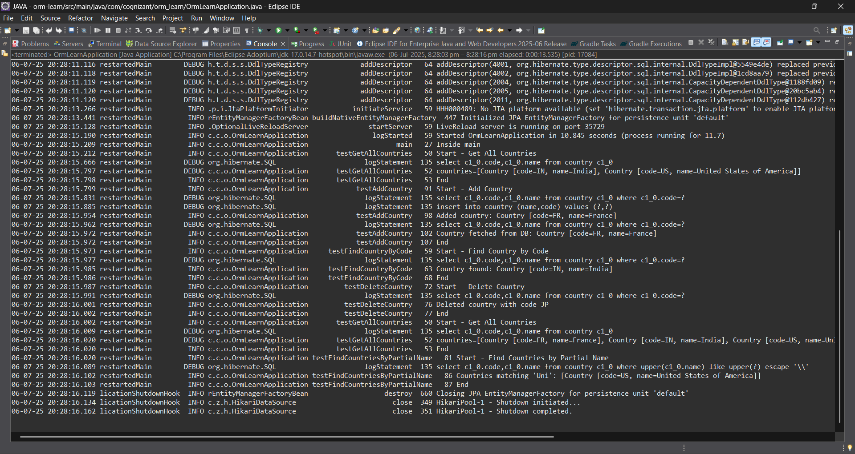

Exercise 9: Delete Country
CountryService.java

package com.cognizant.orm_learn.service;
import com.cognizant.orm_learn.model.Country;
import com.cognizant.orm_learn.service.exception.CountryNotFoundException;
import java.util.List;
import jakarta.transaction.Transactional;
public interface CountryService {
@Transactional
Country findCountryByCode(String code) throws CountryNotFoundException;

@Transactional
void addCountry(Country country);
@Transactional
void updateCountry(String code, String newName) throws CountryNotFoundException;
@Transactional
void deleteCountry(String code);
List<Country> findCountriesByPartialName(String name);
List<Country> getAllCountries();
}

CountryServiceImpl.java
package com.cognizant.orm_learn.service;
import com.cognizant.orm_learn.model.Country;
import com.cognizant.orm_learn.repository.CountryRepository;
import com.cognizant.orm_learn.service.exception.CountryNotFoundException;
import jakarta.transaction.Transactional;
import org.springframework.beans.factory.annotation.Autowired;
import org.springframework.stereotype.Service;
import java.util.List;
import java.util.Optional;
@Service
@Transactional
public class CountryServiceImpl implements CountryService {
@Autowired
private CountryRepository countryRepository;
@Override
public Country findCountryByCode(String code) throws CountryNotFoundException {
Optional<Country> result = countryRepository.findById(code);
if (!result.isPresent()) {
throw new CountryNotFoundException("Country not found with code: " + code);
}
return result.get();
}
@Override
public void addCountry(Country country) {
countryRepository.save(country);
}
@Override
public void updateCountry(String code, String newName) throws CountryNotFoundException {
Country existing = findCountryByCode(code); // reuse with exception handling
existing.setName(newName);
countryRepository.save(existing);
}
@Override
public void deleteCountry(String code) {
countryRepository.deleteById(code);
}
@Override
public List<Country> findCountriesByPartialName(String name) {
return countryRepository.findByNameContainingIgnoreCase(name);
}
@Override
public List<Country> getAllCountries() {
return countryRepository.findAll();
}
}

OrmLearnApplication.java
package com.cognizant.orm_learn;
import com.cognizant.orm_learn.model.Country;
import com.cognizant.orm_learn.service.CountryService;
import com.cognizant.orm_learn.service.exception.CountryNotFoundException;
import java.util.List;
import org.slf4j.Logger;
import org.slf4j.LoggerFactory;
import org.springframework.boot.SpringApplication;
import org.springframework.boot.autoconfigure.SpringBootApplication;
import org.springframework.context.ApplicationContext;
@SpringBootApplication
public class OrmLearnApplication {
private static final Logger LOGGER = LoggerFactory.getLogger(OrmLearnApplication.class);
private static CountryService countryService;
public static void main(String[] args) {
ApplicationContext context = SpringApplication.run(OrmLearnApplication.class, args);
countryService = context.getBean(CountryService.class);
LOGGER.info("Inside main");
testAddCountry();
testUpdateCountry();
testFindCountryByCode();
testDeleteCountry();
testGetAllCountries();
testFindCountriesByPartialName();
}
private static void testAddCountry() {
LOGGER.info("Start - Add Country");
Country country = new Country();
country.setCode("DE");
country.setName("Germany");
countryService.addCountry(country);
LOGGER.info("Added country: {}", country);
LOGGER.info("End");
}
private static void testUpdateCountry() {
LOGGER.info("Start - Update Country");
try {
countryService.updateCountry("DE", "Deutschland");
LOGGER.info("Updated country name for DE to Deutschland");
} catch (CountryNotFoundException e) {
LOGGER.error("Error updating country: {}", e.getMessage());
}
LOGGER.info("End");
}
private static void testFindCountryByCode() {
LOGGER.info("Start - Find Country by Code");
try {
Country country = countryService.findCountryByCode("DE");
LOGGER.info("Country found: {}", country);
} catch (CountryNotFoundException e) {
LOGGER.error("Exception: {}", e.getMessage());
}
LOGGER.info("End");
}
private static void testDeleteCountry() {
LOGGER.info("Start - Delete Country");
countryService.deleteCountry("DE");
LOGGER.info("Deleted country with code DE");
LOGGER.info("End");
}
private static void testGetAllCountries() {
LOGGER.info("Start - Get All Countries");
List<Country> countries = countryService.getAllCountries();
LOGGER.debug("countries={}", countries);
LOGGER.info("End");
}
private static void testFindCountriesByPartialName() {
LOGGER.info("Start - Find Countries by Partial Name");
List<Country> countries = countryService.findCountriesByPartialName("Uni");
LOGGER.info("Countries matching 'Uni': {}", countries);
LOGGER.info("End");
}
}

Output:

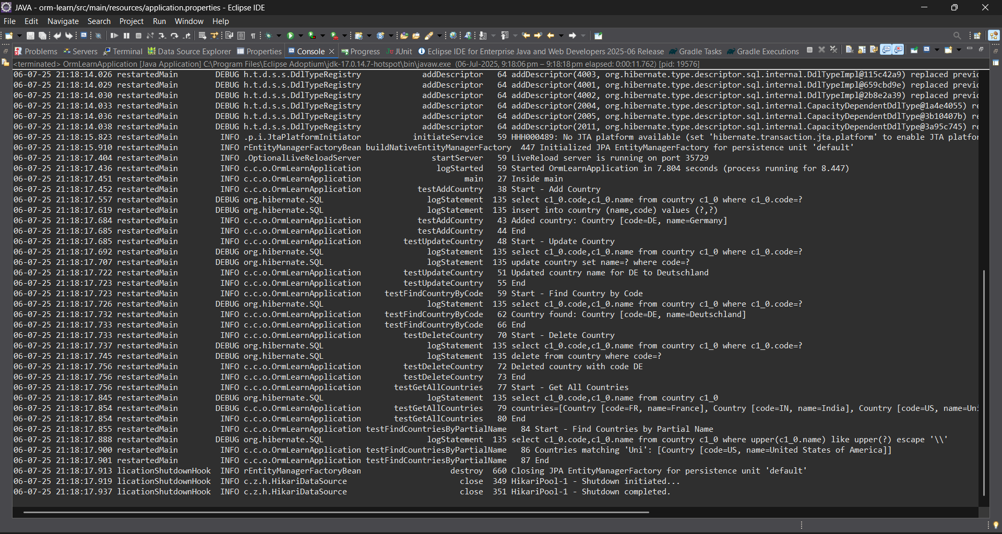

Exercise 4: Get average salary using HQL
Employee.java
package com.cognizant.orm_learn.model;
import jakarta.persistence.*;
import java.util.Date;
import java.util.Set;
@Entity
@Table(name = "employee")
public class Employee {
@Id
@GeneratedValue(strategy = GenerationType.IDENTITY)
@Column(name = "em_id")
private int id;
@Column(name = "em_name")
private String name;
@Column(name = "em_salary")
private double salary;
@Column(name = "em_permanent")
private boolean permanent;
@Column(name = "em_date_of_birth")
private Date dateOfBirth;
@ManyToOne
@JoinColumn(name = "em_dp_id")
private Department department;
@ManyToMany(fetch = FetchType.EAGER)
@JoinTable(
name = "employee_skill",
joinColumns = @JoinColumn(name = "es_em_id"),
inverseJoinColumns = @JoinColumn(name = "es_sk_id")
)
private Set<Skill> skillList;
public int getId() { return id; }
public void setId(int id) { this.id = id; }
public String getName() { return name; }
public void setName(String name) { this.name = name; }
public double getSalary() { return salary; }
public void setSalary(double salary) { this.salary = salary; }
public boolean isPermanent() { return permanent; }
public void setPermanent(boolean permanent) { this.permanent = permanent; }
public Date getDateOfBirth() { return dateOfBirth; }
public void setDateOfBirth(Date dateOfBirth) { this.dateOfBirth = dateOfBirth; }
public Department getDepartment() { return department; }
public void setDepartment(Department department) { this.department = department; }
public Set<Skill> getSkillList() { return skillList; }
public void setSkillList(Set<Skill> skillList) { this.skillList = skillList; }
@Override
public String toString() {
return "Employee [id=" + id + ", name=" + name + ", salary=" + salary +
", permanent=" + permanent + ", dateOfBirth=" + dateOfBirth + "]";
}
}
Department.java
package com.cognizant.orm_learn.model;
import jakarta.persistence.*;
import java.util.Set;
@Entity
@Table(name = "department")
public class Department {
@Id
@GeneratedValue(strategy = GenerationType.IDENTITY)
@Column(name = "dp_id")
private int id;
@Column(name = "dp_name")
private String name;
@OneToMany(mappedBy = "department", fetch = FetchType.EAGER)
private Set<Employee> employeeList;
public int getId() {
return id;
}
public void setId(int id) {
this.id = id;
}
public String getName() {
return name;
}
public void setName(String name) {
this.name = name;
}
public Set<Employee> getEmployeeList() {
return employeeList;
}
public void setEmployeeList(Set<Employee> employeeList) {
this.employeeList = employeeList;
}
@Override
public String toString() {
return "Department [id=" + id + ", name=" + name + "]";
}
}
Skill.java
package com.cognizant.orm_learn.model;
import jakarta.persistence.*;
import java.util.Set;
@Entity
@Table(name = "skill")
public class Skill {
@Id
@GeneratedValue(strategy = GenerationType.IDENTITY)
@Column(name = "sk_id")
private int id;
@Column(name = "sk_name")
private String name;
@ManyToMany(mappedBy = "skillList")
private Set<Employee> employeeList;
public int getId() {
return id;
}
public void setId(int id) {
this.id = id;
}
public String getName() {
return name;
}
public void setName(String name) {
this.name = name;
}
public Set<Employee> getEmployeeList() {
return employeeList;
}
public void setEmployeeList(Set<Employee> employeeList) {
this.employeeList = employeeList;
}
@Override
public String toString() {
return "Skill [id=" + id + ", name=" + name + "]";
}
}
EmployeeRepository.java
package com.cognizant.orm_learn.repository;
import org.springframework.data.jpa.repository.JpaRepository;
import com.cognizant.orm_learn.model.Employee;
public interface EmployeeRepository extends JpaRepository<Employee, Integer> {}
DepartmentRepository.java
package com.cognizant.orm_learn.repository;
import org.springframework.data.jpa.repository.JpaRepository;
import com.cognizant.orm_learn.model.Department;
public interface DepartmentRepository extends JpaRepository<Department, Integer> {}
SkillRepository.java
package com.cognizant.orm_learn.repository;
import org.springframework.data.jpa.repository.JpaRepository;
import com.cognizant.orm_learn.model.Skill;
public interface SkillRepository extends JpaRepository<Skill, Integer> {}
EmployeeService.java
package com.cognizant.orm_learn.service;
import com.cognizant.orm_learn.model.Employee;
import com.cognizant.orm_learn.repository.EmployeeRepository;
import org.springframework.beans.factory.annotation.Autowired;
import org.springframework.stereotype.Service;
import jakarta.transaction.Transactional;
import org.slf4j.Logger;
import org.slf4j.LoggerFactory;
@Service
public class EmployeeService {
private static final Logger LOGGER = LoggerFactory.getLogger(EmployeeService.class);
@Autowired
private EmployeeRepository employeeRepository;
@Transactional
public Employee get(int id) {
LOGGER.info("Start");
return employeeRepository.findById(id).get();
}
@Transactional
public void save(Employee employee) {
LOGGER.info("Start");
employeeRepository.save(employee);
LOGGER.info("End");
}
}
DepartmentService.java
package com.cognizant.orm_learn.service;
import com.cognizant.orm_learn.model.Department;
import com.cognizant.orm_learn.repository.DepartmentRepository;
import org.springframework.beans.factory.annotation.Autowired;
import org.springframework.stereotype.Service;
import jakarta.transaction.Transactional;
@Service
public class DepartmentService {
@Autowired
private DepartmentRepository departmentRepository;
@Transactional
public Department get(int id) {
return departmentRepository.findById(id).get();
}
@Transactional
public void save(Department department) {
departmentRepository.save(department);
}
}
SkillService.java
package com.cognizant.orm_learn.service;
import com.cognizant.orm_learn.model.Skill;
import com.cognizant.orm_learn.repository.SkillRepository;
import org.springframework.beans.factory.annotation.Autowired;
import org.springframework.stereotype.Service;
import jakarta.transaction.Transactional;
@Service
public class SkillService {
@Autowired
private SkillRepository skillRepository;
@Transactional
public Skill get(int id) {
return skillRepository.findById(id).get();
}
@Transactional
public void save(Skill skill) {
skillRepository.save(skill);
}
}
OrmLearnApplication.java
package com.cognizant.orm_learn;
import com.cognizant.orm_learn.model.Department;
import com.cognizant.orm_learn.model.Employee;
import com.cognizant.orm_learn.model.Skill;
import com.cognizant.orm_learn.service.DepartmentService;
import com.cognizant.orm_learn.service.EmployeeService;
import com.cognizant.orm_learn.service.SkillService;
import org.slf4j.Logger;
import org.slf4j.LoggerFactory;
import org.springframework.boot.SpringApplication;
import org.springframework.boot.autoconfigure.SpringBootApplication;
import org.springframework.context.ApplicationContext;
import java.util.Date;
import java.util.HashSet;
import java.util.Set;
@SpringBootApplication
public class OrmLearnApplication {
private static final Logger LOGGER = LoggerFactory.getLogger(OrmLearnApplication.class);
private static EmployeeService employeeService;
private static DepartmentService departmentService;
private static SkillService skillService;
public static void main(String[] args) {
ApplicationContext context = SpringApplication.run(OrmLearnApplication.class, args);
employeeService = context.getBean(EmployeeService.class);
departmentService = context.getBean(DepartmentService.class);
skillService = context.getBean(SkillService.class);
LOGGER.info("Inside main");
testAddEmployee();
testUpdateEmployee();
testGetDepartment();
testAddSkillToEmployee();
}
private static void testAddEmployee() {
LOGGER.info("Start - testAddEmployee");
Employee employee = new Employee();
employee.setName("John Doe");
employee.setSalary(50000.0);
employee.setPermanent(true);
employee.setDateOfBirth(new Date());
Department department = departmentService.get(1);
employee.setDepartment(department);
employeeService.save(employee);
LOGGER.debug("Employee: {}", employee);
LOGGER.info("End");
}
private static void testGetEmployee() {
LOGGER.info("Start - testGetEmployee");
Employee employee = employeeService.get(1);
LOGGER.debug("Employee: {}", employee);
LOGGER.debug("Department: {}", employee.getDepartment());
LOGGER.debug("Skills: {}", employee.getSkillList());
LOGGER.info("End");
}
private static void testUpdateEmployee() {
LOGGER.info("Start - testUpdateEmployee");
Employee employee = employeeService.get(1);
Department newDept = departmentService.get(2);
employee.setDepartment(newDept);
employeeService.save(employee);
LOGGER.debug("Updated Employee: {}", employee);
LOGGER.info("End");
}
private static void testGetDepartment() {
LOGGER.info("Start - testGetDepartment");
Department department = departmentService.get(1);
LOGGER.debug("Department: {}", department);
LOGGER.debug("Employees: {}", department.getEmployeeList());
LOGGER.info("End");
}
private static void testAddSkillToEmployee() {
LOGGER.info("Start - testAddSkillToEmployee");
Employee employee = employeeService.get(1);
Skill skill = skillService.get(2);
Set<Skill> skillList = employee.getSkillList();
if (skillList == null) {
skillList = new HashSet<>();
}
skillList.add(skill);
employee.setSkillList(skillList);
employeeService.save(employee);
LOGGER.debug("Updated Employee with new skill: {}", employee);
LOGGER.info("End");
}
}
Output:
